Annexure3b- Complete filing

INVENTION DISCLOSURE FORM

Details of Invention for better understanding:

- 1. TITLE: Intelligent Climate Control System for Adaptive Temperature and Airflow Management with Optimized Comfort and Energy Efficiency

2. INTERNAL INVENTOR(S)/ STUDENT(S): All fields in this column are mandatory to be filled
A. Full name | Faiz Hasan, Himanshu Shekhar, Priyanshu Singh
Mobile Number | 7279855588, 8176083588, 7250213466
Email (personal) | faizhasan444@gmail.com ,himanshushekharon@gmail.com , priyanshusgh935@gmail.com
UID/Registration number | 12311754, 12318302, 12323241
Address of Internal Inventors | Lovely Professional University, Punjab-144411, India
Signature (Mandatory) | , , 

EXTERNAL INVENTOR(S): (INVENTORS NOT WORKING IN LPU)
A. Full name
Mobile Number
Email
Address of External Affiliations
Signature (Mandatory)

For External Inventors, NOC (No Objection Certificate) from the affiliated institute/university/Industry/lab etc. is mandatory for each individual inventor and their respective topic. For NOC, format is attached below.

(FOR ADDITIONAL INVENTORS, PLEASE ADD ROWS)

3. DESCRIPTION OF THE INVENTION:
The AI-Driven Smart Temperature Control System is an advanced, AI-integrated system that automates temperature and airflow regulation in enclosed spaces. Designed to be installed in air conditioners (ACs), air coolers, and fans, the system leverages IoT, AI-driven predictive analytics, and real-time sensor data to optimize energy consumption while enhancing indoor comfort.
Key functionalities include:
- Automated speed control for AC, coolers, and fans based on real-time temperature, humidity, and occupancy data.
- Energy-efficient operation reducing power wastage.
- Smart learning capabilities to adapt to user preferences over time.
- Mobile app integration for remote monitoring and manual adjustments.
- Predictive maintenance alerts to avoid sudden failures.

- PROBLEM ADDRESSED BY THE INVENTION:
Traditional temperature control devices operate on fixed settings or require manual adjustments, leading to inefficiencies such as:
- Excessive power consumption due to continuous operation at high speeds.
- Uncomfortable room conditions caused by abrupt temperature fluctuations.
- Lack of intelligence in airflow distribution, resulting in uneven cooling or heating.
- Higher maintenance costs due to wear and tear from inefficient usage.
Our invention resolves these inefficiencies with an AI-driven, real-time adaptive control system that dynamically adjusts temperature control settings based on room conditions and occupancy patterns.

- OBJECTIVE OF THE INVENTION (Provide minimum two)
- Real-Time Adaptive Temperature Control:
  - Automate AC, cooler, and fan speed adjustments based on live environmental data.
- Energy Conservation:
  - Optimize power consumption, reducing electricity bills by up to 30%.
- User Comfort Enhancement:
  - Ensure consistent and comfortable temperature levels.
- IoT & Mobile Connectivity:
  - Enable remote control and monitoring via mobile applications.
- Predictive & Preventive Maintenance:
  - AI-driven fault detection and servicing recommendations.
- Smart Learning & Customization:
  - Recognizes user behaviour and adjusts accordingly.

C. STATE OF THE ART/ RESEARCH GAP/NOVELTY:
Sr. No. | Patent I’d | Abstract | Research Gap | Novelty
 | US9429961B2 | AI-based HVAC optimization. | Lacks integration with personal preferences and smart home automation. | Personalized AI-based temperature and airflow adjustment.
 | US11158111B2 | Smart thermostat with occupancy-based climate control. | Limited integration of occupancy data with airflow management. | Occupancy-based ventilation control for optimized air quality and energy efficiency.
 | US10916589B2 | System and method for predictive climate control in buildings. | Static setpoints and reactive climate adjustments. | Proactive climate adjustments based on AI-driven analysis of sensor data. and weather forecasts.

- DETAILED DESCRIPTION:
1. System Components and Working:
- IoT-Enabled Temperature & Humidity Sensors: Measure room conditions at regular intervals for precise environmental monitoring.
- AI Algorithm (Neural Networks): Processes sensor data to determine the optimal cooling and airflow settings.
- Smart Controller Module: Interfaces with ACs, coolers, and fans to regulate temperature and speed automatically.
- Occupancy & Motion Sensors: Detect human presence and adjust temperature control accordingly to prevent energy wastage.
- Cloud-Based Machine Learning Engine: Learns user preferences and room conditions over time to enhance efficiency.
- Mobile App Integration: Allows users to manually adjust settings, schedule operations, and monitor system performance remotely.
- Energy Optimization Unit: Uses predictive AI analytics to reduce unnecessary power consumption.
- Predictive Maintenance System: Analyses component health and alerts users before failures occur.
2. Working Process:
- Data Collection: Sensors continuously monitor room temperature, humidity, and occupancy levels.
- AI Processing: AI analyses historical data and real-time inputs to determine optimal adjustments.
- Automated Control: The system dynamically adjusts AC, fan, and cooler speed to maintain comfort while minimizing energy use.
- Energy Savings Mechanism: AI optimizes device operation to prevent overheating or overcooling, reducing electricity bills.
- User Notifications: The mobile app provides alerts on energy savings, system efficiency, and required maintenance.
- Adaptive Learning: The system refines its adjustments over time based on user behavior and environmental patterns.
3. Advantages of the Detailed System:
- Energy Efficiency: Reduces electricity consumption by up to 30% by preventing unnecessary operation of cooling devices.
- Seamless User Experience: The AI-driven system ensures optimal temperature levels without manual intervention.
- Extended Device Lifespan: Predictive maintenance reduces wear and tear on ACs, coolers, and fans.
- Cost Savings: Automated energy control significantly lowers utility bills.
- Remote Accessibility: Mobile app integration allows control from anywhere, providing convenience and flexibility.
- Eco-Friendly Impact: Reducing energy usage contributes to lower carbon footprints and sustainable energy management.
- Adaptive Personalization: Learns and adapts to user behaviour, providing tailored temperature control solutions.

- RESULTS AND ADVANTAGES:
1. Automated Temperature Regulation
Results:
- Ensures optimal cooling by dynamically adjusting airflow and cooling power.
- Reduces energy consumption by optimizing cooling efficiency.
- Enhances comfort by maintaining consistent temperature levels.
Advantages:
- Energy Efficiency: Reduces power usage by up to 30% compared to conventional systems.
- Cost Savings: Lowers electricity bills through AI-driven optimization.
- Enhanced Comfort: Maintains uniform cooling without temperature fluctuations.
- Smart Adaptability: Adjusts cooling based on environmental conditions and user preferences.
2. AI-Based Predictive Maintenance
Results:
- Detects potential system failures before they occur.
- Reduces downtime and prolongs equipment lifespan.
- Optimizes system efficiency by identifying wear and tear.
Advantages:
- Increased Reliability: Minimizes unexpected breakdowns.
- Lower Maintenance Costs: Reduces the need for frequent manual servicing.
- Data-Driven Insights: Provides actionable recommendations for upkeep.
- Improved System Longevity: Enhances the lifespan of cooling units.
3. Intelligent Air Quality Monitoring
Results:
- Continuously monitors and adjusts indoor air quality.
- Detects pollutants and allergens in real-time.
- Ensures a healthier indoor environment.
Advantages:
- Health Benefits: Reduces exposure to harmful pollutants.
- Automated Adjustments: Enhances air purification dynamically.
- Smart Alerts: Notifies users when air quality deteriorates.
- Seamless Integration: Works with existing HVAC systems for enhanced efficiency.

- EXPANSION:
Expanded Capabilities of the AI-Driven Cooling System
1. Automated Temperature Regulation
- Dynamic tempr Adaptation: Adjusts cooling based on seasonal and weather variations, ensuring consistent performance throughout the year.
- User-Specific Preferences: Learns from individual habits and usage patterns to customize cooling preferences for maximum comfort.
- Integration with Smart Grids: Synchronizes with smart energy networks to optimize power consumption based on electricity demand and supply fluctuations.
- Environmental Sensing: Utilizes IoT-based environmental sensors to assess room occupancy, humidity, and external weather conditions for real-time cooling adjustments.
2. AI-Based Predictive Maintenance
- Sensor-Based Fault Detection: Employs IoT sensors to identify performance anomalies, component degradation, and potential system failures before they escalate.
- Self-Learning Mechanisms: Utilizes machine learning algorithms to enhance predictive accuracy by continuously learning from maintenance data and historical trends.
- Remote Diagnostics: Enables off-site monitoring and issue resolution, allowing technicians to diagnose and resolve issues without requiring on-site visits.
- Automated Repair Recommendations: Provides users with AI-driven suggestions for minor maintenance actions to prolong system life and efficiency.
3. Intelligent Air Quality Monitoring
- Advanced Filtration Management: Automatically adjusts air filters based on pollutant levels, optimizing efficiency while reducing unnecessary replacements.
- Multi-Zone Air Quality Control: Implements room-specific air purification strategies, ensuring customized air quality enhancement for different areas within a building.
- AI-Powered Learning: Continuously improves air quality adjustments using historical data, adapting purification methods to seasonal changes and user preferences.
- Smart Ventilation Control: Works in tandem with ventilation systems to regulate fresh air intake, balancing energy efficiency and optimal air circulation.

G. WORKING PROTOTYPE/ FORMULATION/ DESIGN/COMPOSITION: Is your working prototype or other ready. Provide the images/data of the prototype. If no, how much time is required for the same?
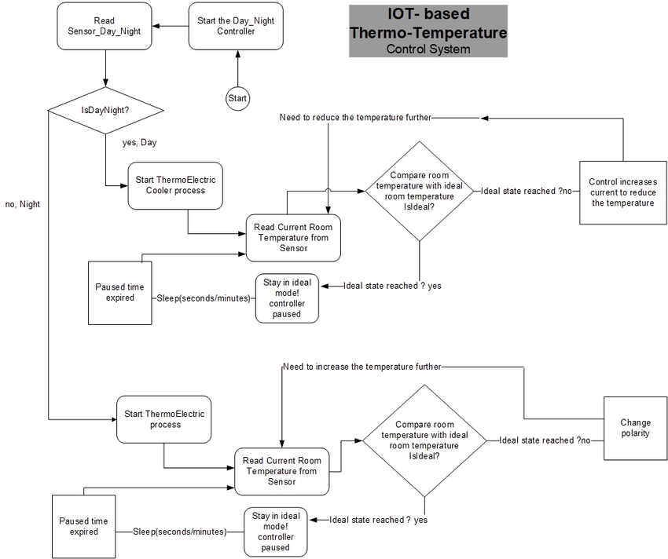
Flow chart of the IoT-based temperature control system.
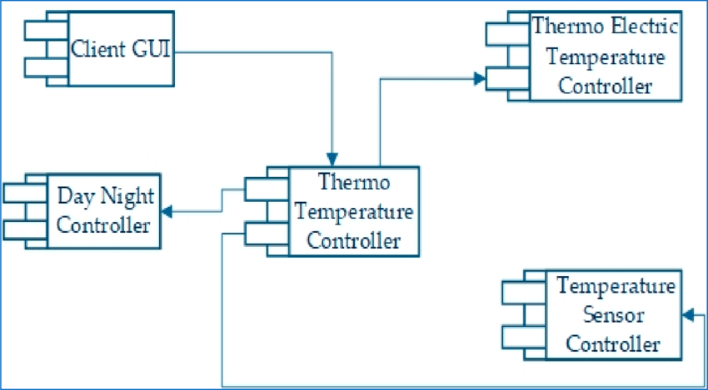
Software component model for the IoT-based temperature control system.
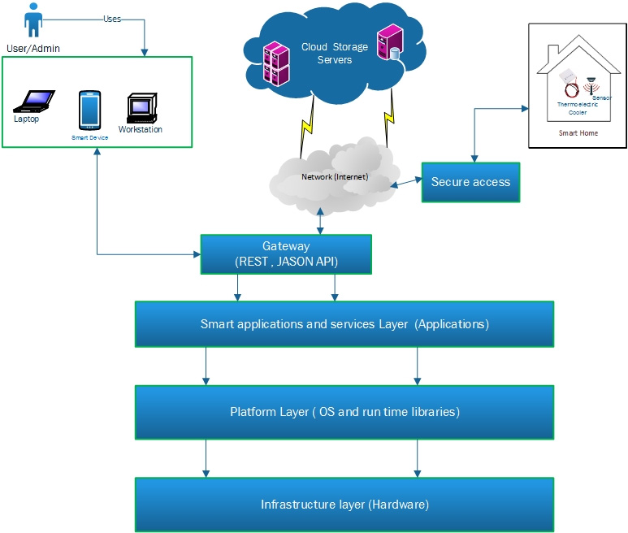
Simple air management framework: integrating IoT and cloud computing.

G. EXISTING DATA: NA

4. USE AND DISCLOSURE (IMPORTANT): Please answer the following questions:

- Have you described or shown your invention/ design to anyone or in any conference? | YES ( ) | NO (no)
- Have you made any attempts to commercialize your invention (for example, have you approached any companies about purchasing or manufacturing your invention)? | YES ( ) | NO (no)
- Has your invention been described in any printed publication, or any other form of media, such as the Internet? | YES ( ) | NO (no)
- Do you have any collaboration with any other institute or organization on the same? Provide name and other details. | YES ( ) | NO (no)
- Name of Regulatory body or any other approvals if required.  India: Bureau of Energy Efficiency (BEE),  Ministry of Environment, Forest and Climate Change.  GDPR (General Data Protection Regulation, EU).  DPDP Act (India) – Ensures personal data protection compliance. CCPA (California Consumer Privacy Act, USA). | YES (yes) | NO ( )

- Provide links and dates for such actions if the information has been made public (Google, research papers, YouTube videos, etc.) before sharing with us: NA

6. Provide the terms and conditions of the MOU also if the work is done in collaboration within or outside university (Any Industry, other Universities, or any other entity): NA

7. Potential Chances of Commercialization.
The global market for smart temperature control systems is expanding rapidly as more households and businesses seek energy-efficient and automated solutions. With rising concerns about climate change and energy conservation, governments and corporations are actively promoting AI-powered home automation technologies.
- Growing Demand for Smart Home & Industrial Automation:
  - With the increased adoption of smart home devices, consumers are shifting toward automated cooling and heating solutions.
  - Industries and commercial buildings are looking for cost-effective energy solutions to optimize HVAC systems.
- Revenue Models:
  - Subscription-Based AI Optimization Services: Offer a tiered subscription model where users pay for advanced AI features like adaptive learning and predictive maintenance.
  - IoT Hardware Sales: Commercializing sensor modules and smart controllers for integration with existing ACs, fans, and coolers.
  - B2B Partnerships: Collaborating with AC, cooler, and fan manufacturers to integrate AI-driven optimization within their existing product lines.
  - OEM Licensing Model: Licensing AI algorithms to HVAC manufacturers to incorporate into their proprietary systems.
- Government & Corporate Funding Opportunities:
  - Energy-efficient initiatives: Many governments offer incentives for energy-saving innovations.
  - Smart city development: Companies investing in smart infrastructure could incorporate this system into large-scale projects.
- Competitive Advantage:
  - AI-powered automation outperforms traditional thermostat-based controls, reducing energy wastage.
  - Easy retrofitting with existing cooling devices makes adoption simple.
  - Cloud-based predictive analytics gives users real-time insights and remote access.

- List of companies which can be contacted for commercialization along with the website link:
Several Indian companies specialize in smart home automation, IoT-based cooling systems, and AI-driven energy management solutions. Partnering with these companies can accelerate commercialization and widespread adoption:
- Havells India Ltd.
  - A leading manufacturer of electrical equipment, including smart ACs and cooling devices.
  - Website: https://www.havells.com
- Voltas Limited
  - One of India's biggest AC manufacturers, known for energy-efficient and smart cooling solutions.
  - Website: https://www.voltas.com
- Godrej Appliances
  - Focuses on eco-friendly and energy-efficient cooling devices, making them an ideal commercialization partner.
  - Website: https://www.godrej.com
- Schneider Electric India
  - A global leader in energy management solutions, actively investing in smart home and industrial automation.
  - Website: https://www.se.com/in/en
- L&T Electrical & Automation
  - Provides advanced IoT-enabled home automation solutions that can be integrated with smart temperature control systems.
  - Website: https://www.lntebg.in
- Tata Power – Smart Energy Solutions
  - Specializes in energy efficiency projects, offering a potential collaboration for smart temperature control commercialization.
  - Website: https://www.tatapower.com
By partnering with these companies, the AI-Driven Smart Temperature Control System can be integrated into consumer and industrial markets, ensuring a sustainable, energy-efficient future.

9. Any basic patent which has been used and we need to pay royalty to them. NA

10. FILING OPTIONS: Please indicate the level of your work which can be considered for provisional/ complete/ PCT filings (Complete).

11. KEYWORDS: Please provide right keywords for searching your invention.
- AI-Driven Temperature Control
- Smart Airflow Optimization
- IoT-Based Temperature System
- Energy-Efficient Cooling
- Intelligent Fan & AC Control
- Adaptive Temperature Regulation
- Predictive Maintenance AI

NO OBJECTION CERTIFICATE
This is to certify that University/Organization Name or its associates shall have no objection if Lovely Professional University files an IPR (Patent/Copyright/Design/any other…….) entitled "…………………." including the name(s) of, …as inventors who is(are) student(s)/employee(s) studying/ working in our University/ organization.
Further Name of the University/Organization shall not provide any financial assistance in respect of said IPR nor shall raise any objection later with respect to filing or commercialization of the said IPR or otherwise claim any right to the patent/invention at any stage.

(Authorised Signatory)

